# Assignment 17

# Ec2 instance

We have the instance id displayed and

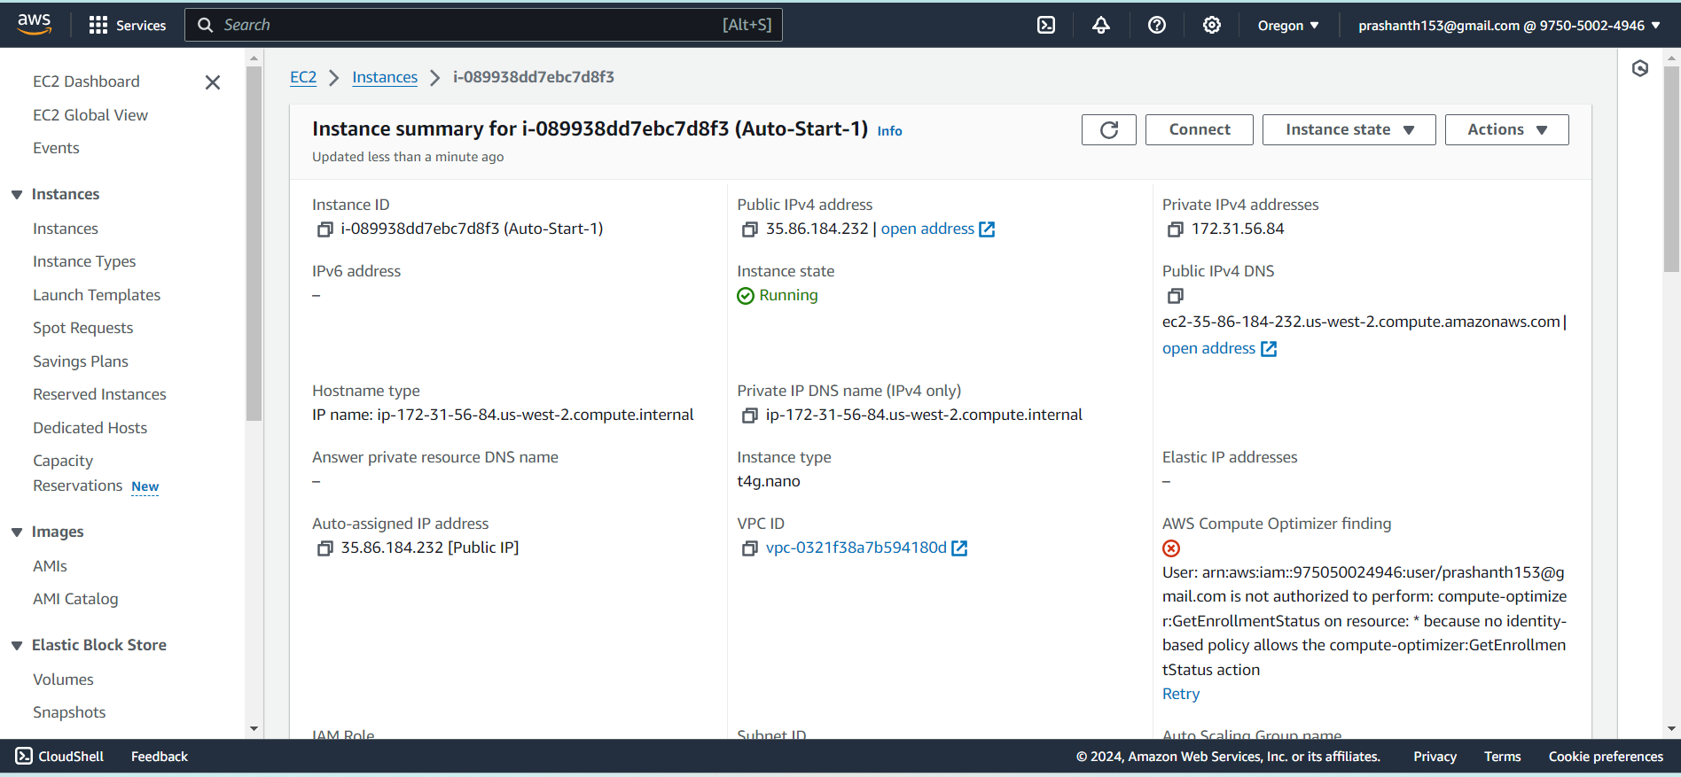

Availability zone is us-west-2d

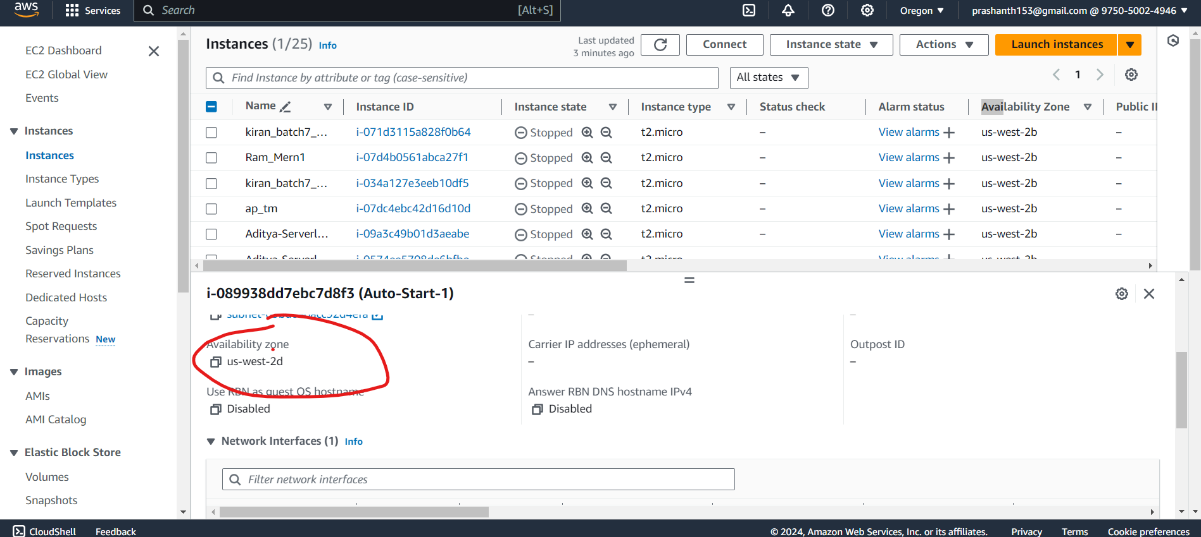

# Snapshot availability manually

Below is the volume information 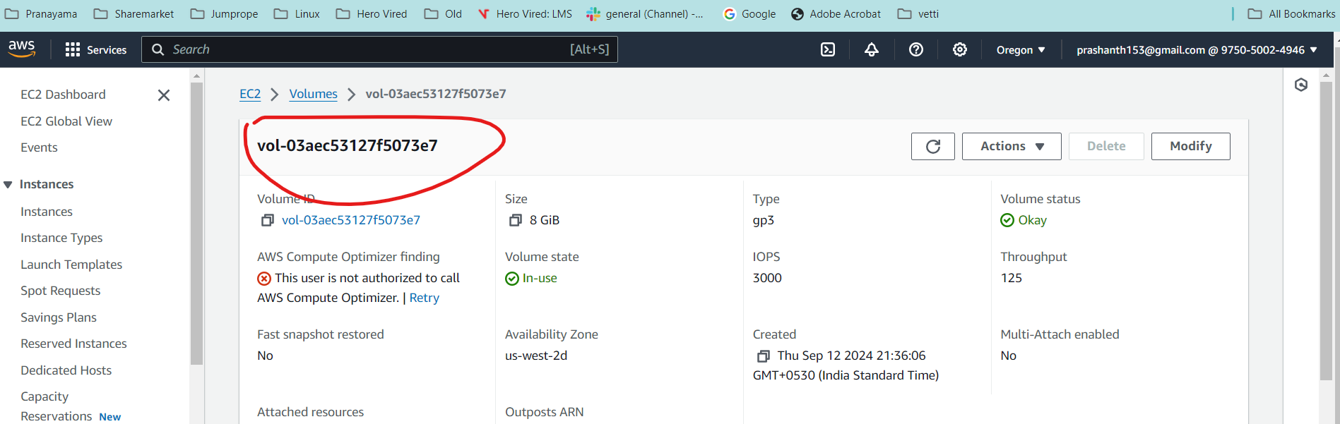

2 snapshots were created by me for this volume

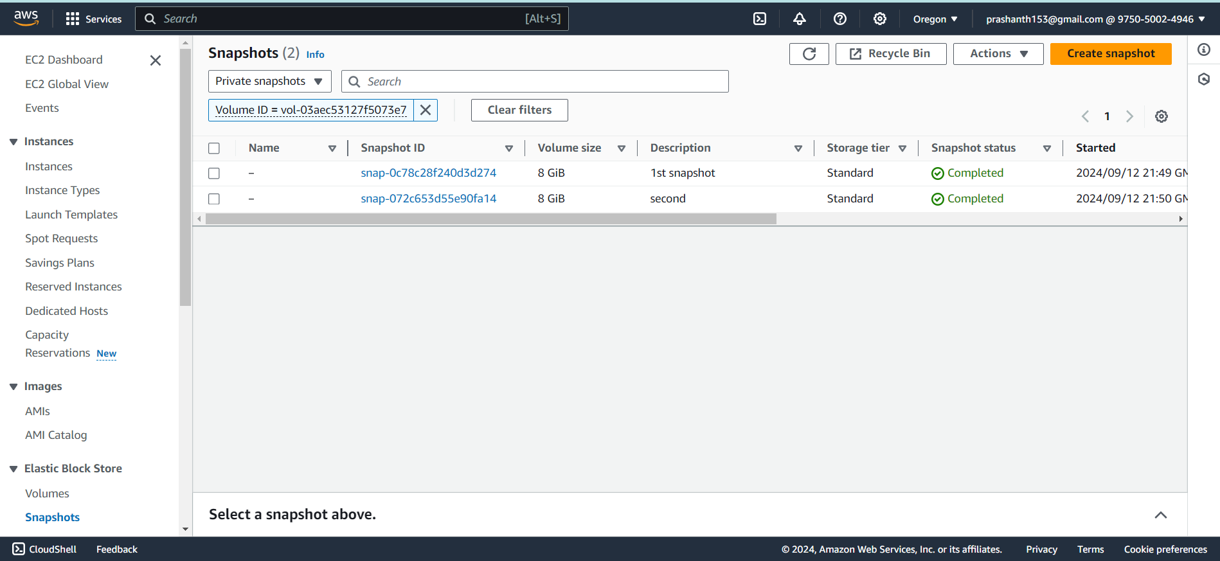

# Lambda function - Create a new EC2 instance using the fetched snapshot.

Creating the lambda function

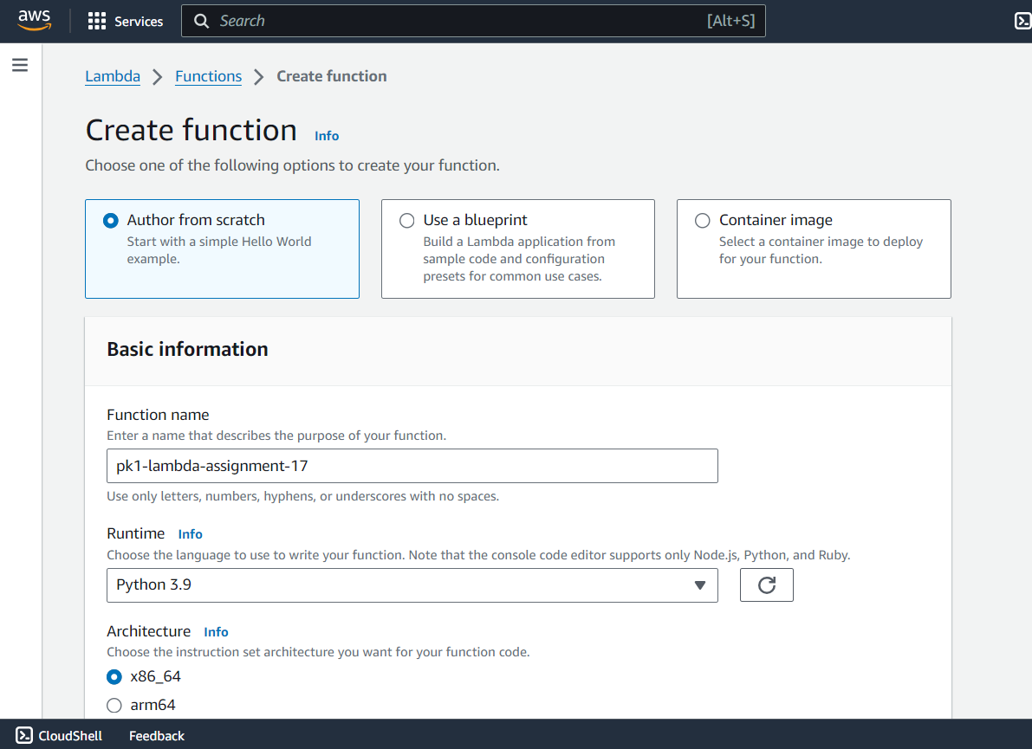

Role is ec2 full access

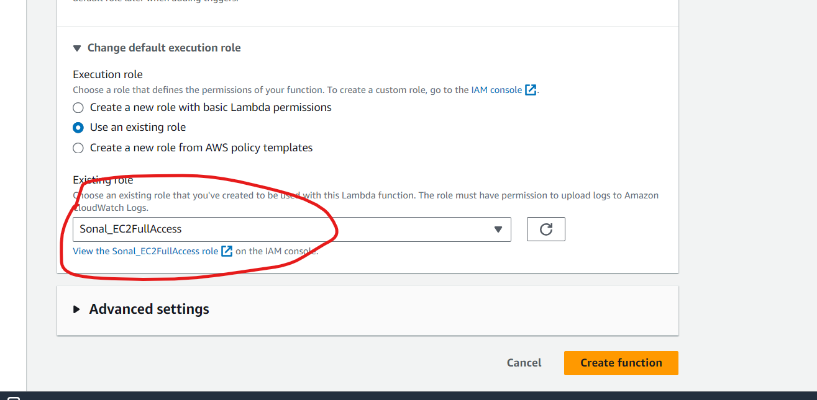

Execute the lambda function and it was a success as shown below

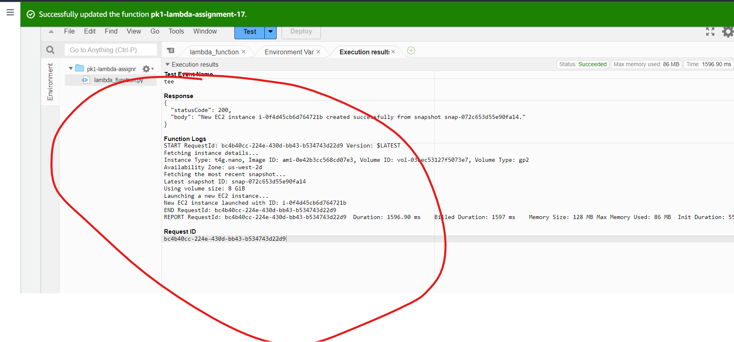

# New Ec2 instance created with similar properties

